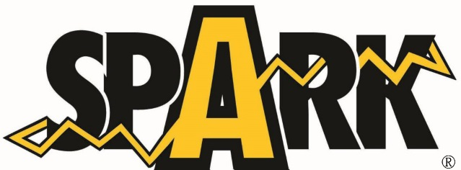

Vehicle Donation Information

Donation Date:

I want my vehicle to go to:
- Hylton High School Automotive Program
- Osbourn Park High School Automotive Program
- No preference

Owner/Contact Information
Name (First and Last):

Address:

Phone Number:

Email:

Vehicle Information

Vehicle Year:

Vehicle Make:

Vehicle Model:

Vehicle Color:

Number of Doors:

Vehicle ID# (VIN):

Do you have the title for the vehicle?

Approximate Mileage:

Is the vehicle in running condition?

Please explain vehicle condition:

